Passive Information Gathering
Website Recon & Foot printing
Whatis
Host
Robots.txt file
sitemap.xml
Builtwith
Wappalyzer
Whatweb hackersploit.org
httrack

Website Recon & Foot printing:
Recon = Information gathering
Footprinting = Structured mapping of that information

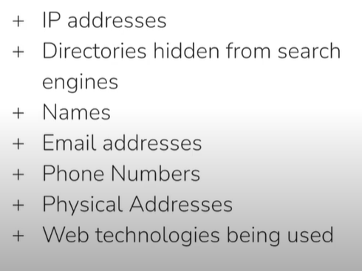
Practical:
https://hackersploit.org/ on this one.

Linux:
Whatis command – tell about the commmad
host = tool to check domain ↔ IP info via DNS.

if when we find the ip address of the domain and it return the 2 ip address or more then it’s mean the there is the proxy/firewall in place on it.
Not always, but often yes — especially when using services like Cloudflare, Akamai, or AWS CloudFront.

Feature | Firewall | Proxy
Role | Blocks/allows traffic | Forwards traffic on behalf of user
Position | Between internal network and outside | Between user and destination server
Main Use | Security (blocking threats) | Privacy, filtering, access control, caching
Visibility | Sees IPs, ports, protocols | Sees full requests (URLs, content, headers)

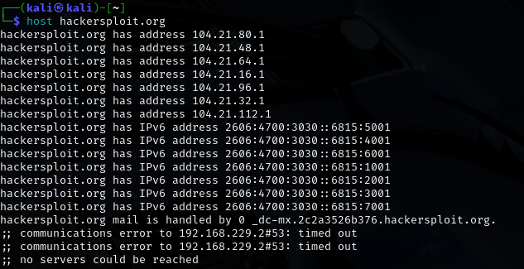

Here their it give the multiple ip addresses there is the chance that the firewall is set.
We also have to look at the social media attach to it.(to get the email ,usernames of the employee which will help later to phishing etc.)
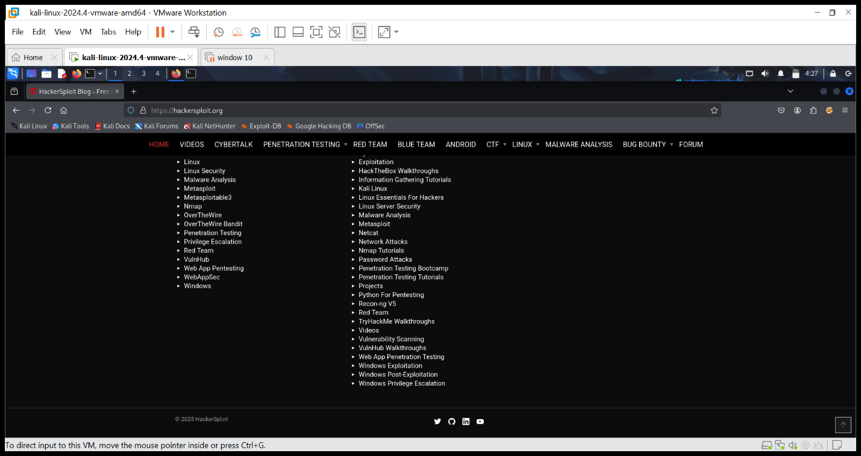

When we are performing or collecting info then the best place to start is the robots.txt file.

Good practice.
Robots.txt file:
Which files/folder you don’t want search engine to index are listed in it approx. all the website have this file.
Search engine check it to display only the allowed directories and the files.(crawling)
What it is: A plain-text file placed at the root of a website (https://example.com/robots.txt) that tells web crawlers (e.g., Googlebot) which parts of the site they may or may not crawl and index.
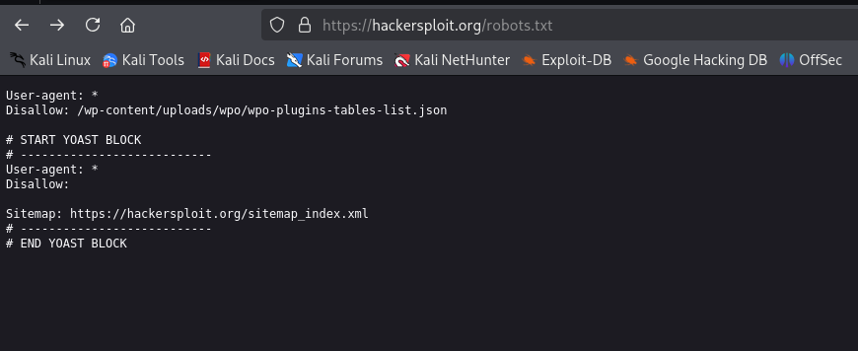
🗺️ sitemap.xml
- What it is: An XML file (usually at https://example.com/sitemap.xml) that lists all publicly available URLs on the site, along with metadata like when they were last updated.
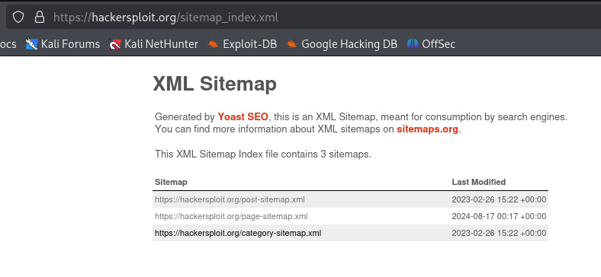
For the website technologies:
Firefox addons:
Builtwith
Wappalyzer

Then commands:
Whatweb hackersploit.org
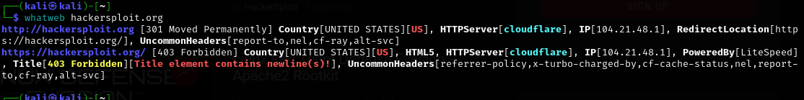

For copying the code of the website:
sudo apt install httrack

